The IN parameter example

The following example illustrates how to use the IN parameter in the GetOfficeByCountry stored procedure that selects offices located in a particular country.



|  |  |
| --- | --- |
| 1  2  3  4  5  6  7  8 | DELIMITER //  CREATE PROCEDURE GetOfficeByCountry(IN countryName VARCHAR(255))  BEGIN  SELECT *  FROM offices  WHERE country = countryName;  END //  DELIMITER ; |

The countryName is the IN parameter of the stored procedure. Inside the stored procedure, we select all offices that locate in the country specified by the countryName parameter*.*

Suppose, we want to get all offices in the USA, we just need to pass a value (USA) to the stored procedure as follows:



|  |  |
| --- | --- |
| 1 | CALL GetOfficeByCountry('USA'); |

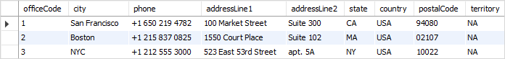

To get all offices in France, we pass the France literal string to the GetOfficeByCountry  stored procedure as follows:



|  |  |
| --- | --- |
| 1 | CALL GetOfficeByCountry('France') |

http://www.mysqltutorial.org/wp-content/uploads/2009/12/MySQL-IN-parameter-offices-in-France.png